

Midterm Project Report

Advanced Computer Programming

Student Name : Khulegu Tumennast
Student ID : 114021139
Teacher : DINH-TRUNG VU

2026-04

Introduction

Github
- Personal Github Account: https://github.com/khulegu1025-ui
- Group Project Repository: https://github.com/khulegu1025-ui/ACP-Group3

Overview
In this project, I used advanced Python features including scrapy and XPath/CSS Selector to successfully get information such as URL, name, last update, programming language and commit counts from each repositories located on my page(https://github.com/khulegu1025-ui).

Implementation

Class 1 GithubDeepSpider
This is the main spider class that is inherited from scrapy.Spider

Fields
Name: The unique indentifier for the spider, set to ‘github’
Start_urls: a list containing the entry point: https://github.com/khulegu1025-ui?tab=repositories.

Methods
• parse(self, response):
- Iterates through each repository block on the main list.
- Extracts the repository URL, Name, and Last Updated timestamp.
- Triggers a new scrapy.Request for each repository URL to perform a "Deep Crawl".
• parse_repo_details(self, response):
- The callback method that processes the internal page of each repository.
- Uses the meta attribute to maintain data continuity from the parse method.

Functions
- Response.css(‘…’).getall() : Used to capture the full list of languages (HTML, CSS, JavaScript) rather than just the primary one.
- Strip() and replace() : Standard string functions used to clean extracted text, removing extra whitespace and the word "Commits" from the numeric count.

Results

Result 1 Successful deep Extraction
. The program successfully navigated from the repository to individual pages to capture data that is not visible on the main profile.
Main-Portfolio: Extracted 5 Commits and multiple languages (CSS, HTML, JavaScript).
Portfolio: Extracted 15 Commits and multiple languages (HTML, CSS, JavaScript).

Result 2 Requirement Compliance (Notes 1 & 2)
About repositories like “Turshilt” that has no commit history and language, The scrapy will not get the counts of commitment and languages. Instead of that, the scrapy will show none.
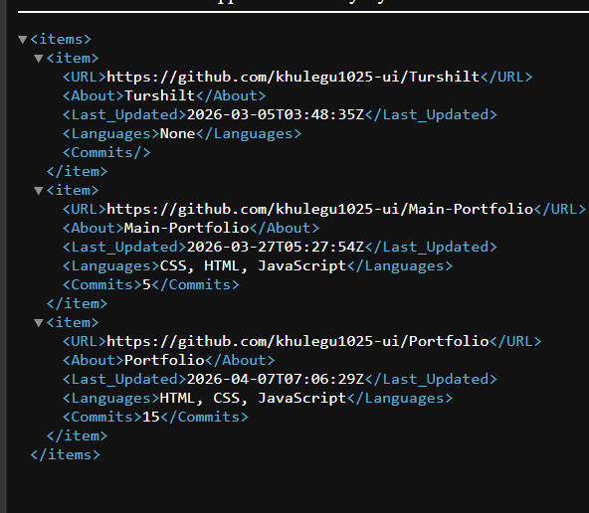
.

Conclusions
The implementation shows that web scrapping often requires multi-layered navigation to retrieve all necessary data. By using Scrapy’s callback system, the spider can bypass the limitations of the GitHub summary page. The final XML output provides a structured, accurate representation of the user’s repository activities, meeting all the requirements specified in the assignment.
Moreover, I tested my program on other people’s repository page and it successfully extracted all the necessary information from each pages.

